Data Mining Assignment 2 - Clustering
By team members:
Basmala Mohsen El-Batran 20237020
Jumanah Muhammed Ali 20237003
Malak Moustafa Abdel-Maboud 20237015
Laila Mohamed Shawky 20236076

1. Application Goal
The objective of this project is to perform customer segmentation using clustering techniques.
Customer segmentation aims to group customers based on similar characteristics in order to improve marketing strategies and decision-making.
By identifying different customer groups, businesses can:
- Target specific customer segments
- Personalize marketing campaigns
- Improve customer satisfaction

2. Dataset Description
The dataset used in this project is the Mall Customers Dataset, which was obtained from an online public repository (Kaggle).
This dataset contains information about customers visiting a shopping mall. Each record represents a single customer and includes demographic and behavioral attributes.
The dataset is suitable for clustering tasks because it contains meaningful numerical features that clearly represent customer behavior and allow effective grouping.
The dataset contains no missing values and is well-structured, making it suitable for preprocessing and clustering analysis.

3. Selected Features
For clustering purposes, the following features were selected:
- Age → Represents the customer's age
- Annual Income (k$) → Represents the yearly income of the customer
- Spending Score (1–100) → Represents how much the customer spends in the mall
These features were chosen because they provide insights into customer lifestyle, financial capability, and spending behavior.

4. Clustering Tendency (Hopkins Statistic)
To evaluate whether the dataset is suitable for clustering, the Hopkins Statistic was used.
The Hopkins Statistic measures the clustering tendency of a dataset:
- Values close to 1 indicate a strong clustering tendency.
- Values around 0.5 indicate a random distribution.
- Values close to 0 indicate a uniform distribution.
In this project, the Hopkins Statistic value was computed as:
H = 0.7339
This result indicates that the dataset has a good clustering tendency, as the value is clearly higher than 0.5 and close to 0.75. This means that the data points are not randomly distributed and are likely to form meaningful clusters.
Therefore, the dataset is suitable for applying clustering algorithms such as K-Means and DBSCAN.

5. Conclusion
The Mall Customers dataset is appropriate for clustering because:
- It contains relevant numerical features such as Age, Annual Income, and Spending Score.
- It reflects real-world customer behavior.
- It shows a good clustering tendency based on the Hopkins Statistic result.
Thus, the dataset is suitable for clustering analysis, and applying clustering techniques such as K-Means and DBSCAN is justified.
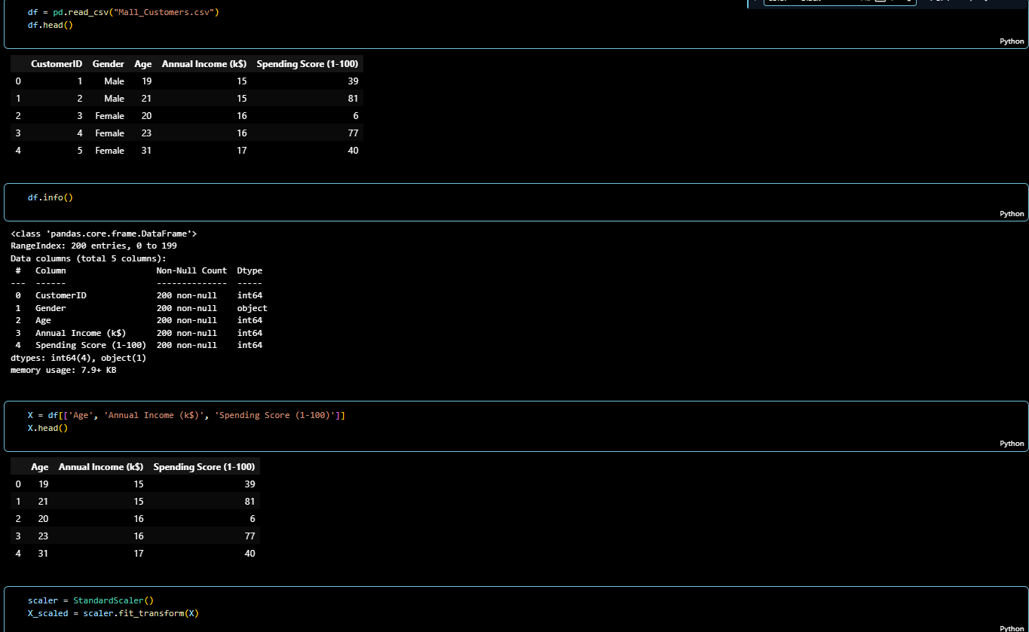
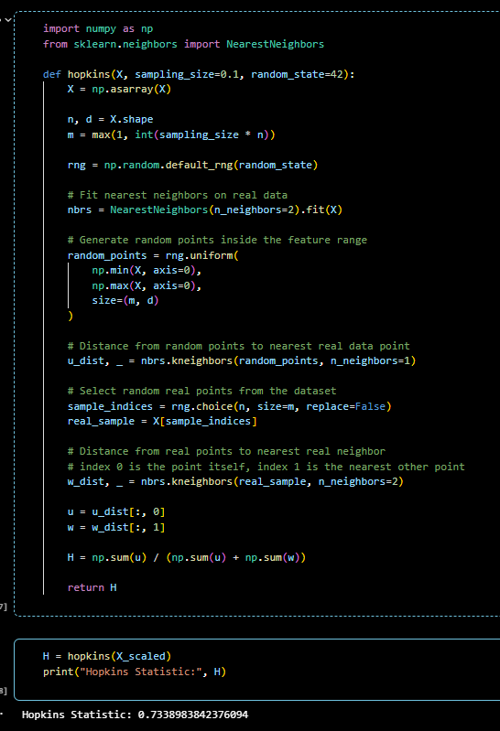

6. Selecting number of clusters
This was done by comparing three different evaluation methods.

The empirical rule suggested K=10, however this method is purely formula-based and does not reflect the actual data distribution, so it was used only as an upper bound reference.
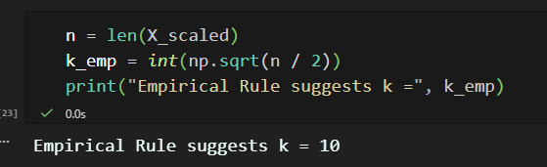
The Elbow Method indicated that WCSS begins to flatten after K=5, suggesting diminishing returns beyond that point.
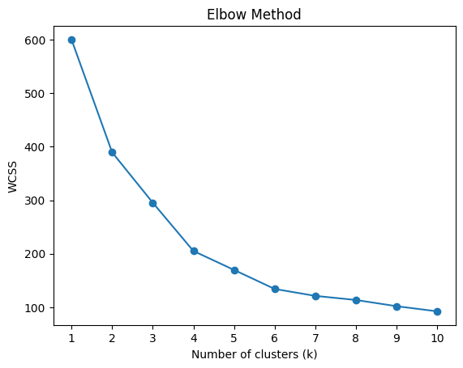
Since clustering is an unsupervised task with no ground truth labels, the Silhouette Score was used as the cross-validation method to internally validate the cluster quality. It measures how well-separated and cohesive the clusters are, serving the same purpose as cross-validation does in supervised learning. The Elbow Method further supported this, showing that WCSS begins to flatten after K=5, indicating diminishing returns beyond that point. The Silhouette Score peaked at K=6, and given that both methods converge around the same region, K=6 was selected as the optimal number of clusters.
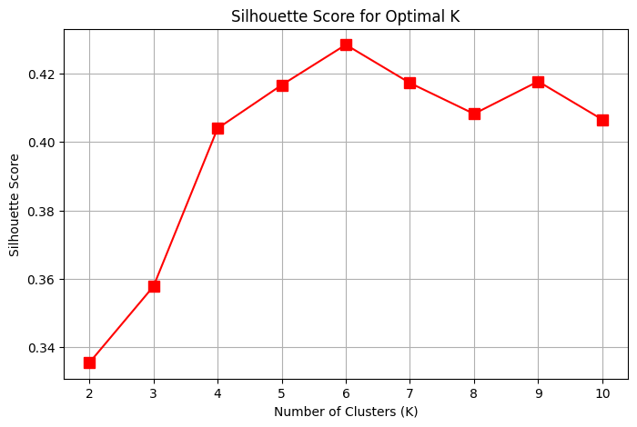

7. Applying K-Mean & DB Scan clustering algorithms
The goal of this analysis was to segment customers based on their Age, Annual Income, and Spending Score using two clustering algorithms: K-Means and DBSCAN, and compare their behavior and results.

K-Means Clustering Results
K-Means was applied with 6 clusters, which produced a detailed segmentation of customers.

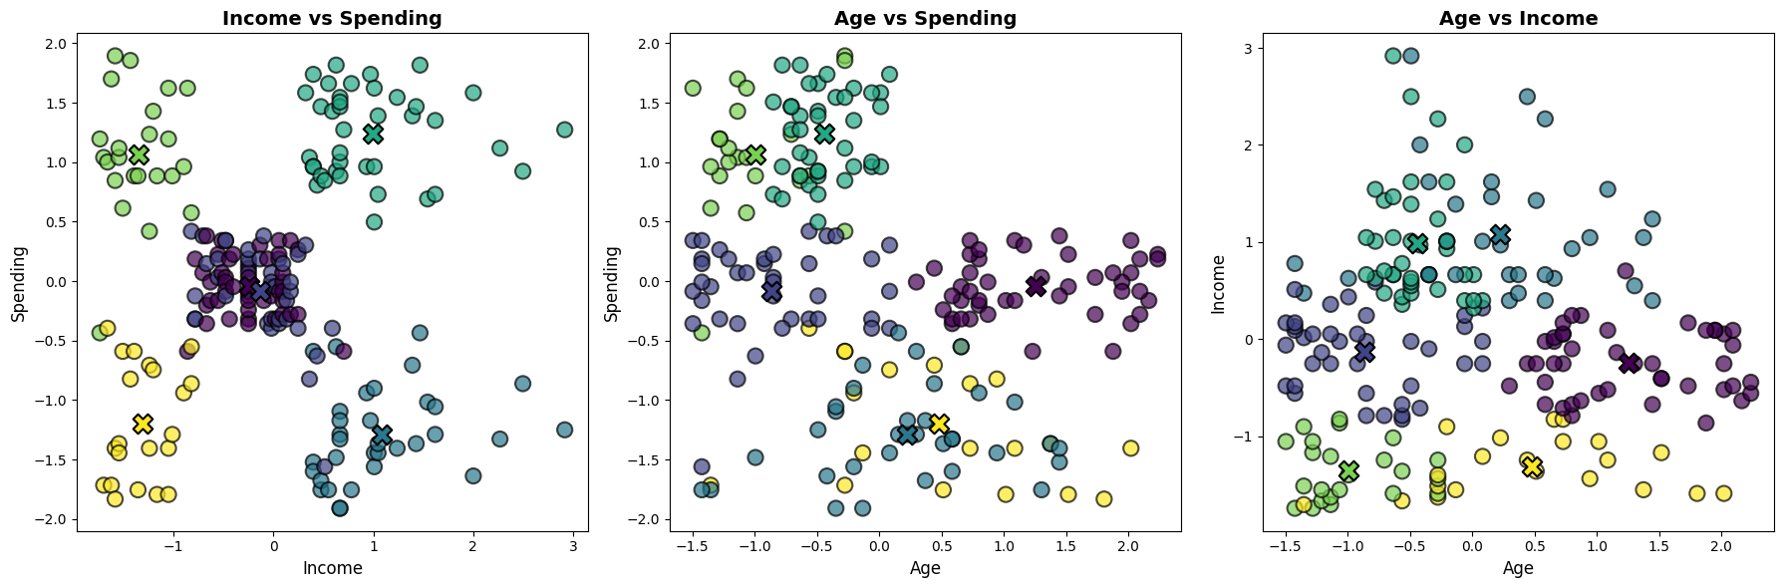

Cluster Interpretation:

Cluster Color | Income | Spending | Age | Persona
Teal | High | High | Middle | VIP / Stars
Light Green | Low | High | Young | Trendsetters
Yellow | Low | Low | Old/Mid | Thrift Seekers
Dark Blue | High | Low | Old/Mid | Conservative Wealth
Purple | Mid | Mid | Mixed | Standard Customer

Key Insights:
K-Means provides fine-grained segmentation, making it useful for marketing strategies and customer targeting.The 3rd subplot isn’t so informative it can be kept, it might be needed in the future.
Our interpretation of each cluster, what it might be into:
VIPs (Teal): High-income, high-spending middle-aged adults who value premium service and loyalty rewards.
Thrift Seekers (Yellow): Low-income, low-spending older adults who prioritize value, essentials, and discounts.
Trendsetters (Light Green): Younger individuals with lower income but high spending habits, driven by trends and social media.
Conservative Wealth (Dark Blue): High-income, low-spending mature adults who focus on quality and long-term investment over flashiness.
Standard (Purple): Middle-income, middle-spending average consumers who seek consistency and reliability.
DBSCAN (Density-Based Spatial Clustering of Applications with Noise)
To implement DBSCAN, we needed to determine two key parameters: min_samples and eps

The K-Distance Method
We calculated the distance to the 5th nearest neighbor for every data point (where k = 2*{features} - 1). By plotting these distances in descending order, we look for the "elbow"—the point of maximum curvature where the density begins to drop significantly.
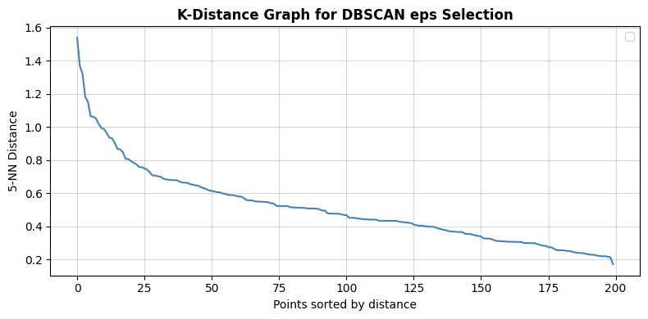epsilon value is between 0.6 to 0.7, so we tested it using Silhouette Analysis:
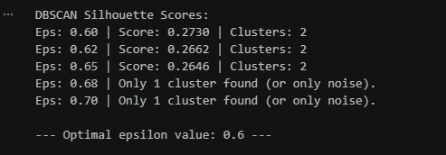
Result: epsilon = 0.60 yielded the highest Silhouette Score of 0.2730.
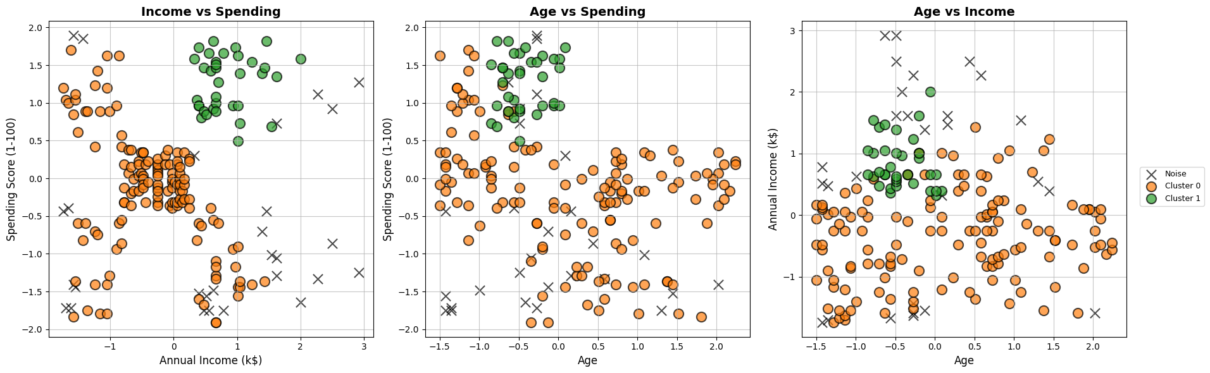
Using epsilon = 0.6 and min_samples = 5, the algorithm identified 2 primary clusters and a significant amount of noise.
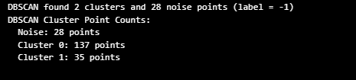
Group | Count | Profile Description
Cluster 0 | 137 points | The "Mass Market": Average age (~41), moderate income, and moderate spending.
Cluster 1 | 35 points | The "Elite Group": Younger (~32), high income, and very high spending.
Noise (-1) | 28 points | Outliers: Points that did not belong to any dense region.

Comparison: DBSCAN vs. K-Means
DBSCAN and K-Means provided very different perspectives on this dataset:

K-Means (The Granular View)
- Structure: Forced every point into one of 6 clusters.
- Pros: Highly actionable for marketing; separated "Budget Conscious," "Aspiring Youth," and "Conservative Wealth" into distinct categories.
- Cons: Sensitive to outliers; might create clusters where the density is actually quite low.

DBSCAN (The Density View)

- Structure: Identified only two truly dense regions and labeled 14% of the data as noise.
- Pros: Robust to outliers. It tells us that while K-Means found 6 groups, only the "Average" and "High-Spending Elite" groups are statistically dense enough to be considered reliable clusters.
- Cons: Fails to distinguish between the lower-income subgroups (Thrift Seekers vs. Trendsetters) because they are geographically sparse in the vector space.

Conclusion & Recommendation
- For targeted marketing: K-Means is superior as it provides more specific segments (like the "Aspiring Youth").
- For data integrity: DBSCAN's "Noise" label is valuable for identifying unique customers who don't fit standard patterns.
- Final Verdict: Use the 6-cluster K-Means model for business strategy, but keep the DBSCAN noise list as a secondary "special interest" group for one-to-one personalized marketing.
---------------------------------------------------------------------------------------------

Quality Testing & Discussion

1. Extrinsic Quality Testing (Recall)
The Mall Customers dataset does not contain a ground-truth cluster label. Extrinsic metrics — which measure how well a clustering matches a known reference partition — therefore cannot be computed for this dataset.

If ground-truth labels were available, Recall for each cluster k would be defined as:
Recall_k = (# true-class members assigned to cluster k) / (# total members of that true class)
and averaged in macro fashion across all true classes. Other common extrinsic metrics include Purity, Adjusted Rand Index (ARI), and Normalized Mutual Information (NMI).

2. Intrinsic Quality Testing

2.1 Chosen Primary Metric: Silhouette Score
The Silhouette Score was selected as the primary intrinsic metric for the following reasons:
- No ground truth available — intrinsic metrics are the only option when cluster labels are absent.
- Algorithm-agnostic — the Silhouette Score is computed from pairwise distances alone, making it valid for both K-Means and DBSCAN (applied on non-noise points).
- Interpretable scale — values lie in [-1, 1], where values > 0.5 indicate reasonable structure, 0.25–0.5 indicate weak structure, and values near 0 or below indicate overlapping clusters.
- Per-point resolution — unlike Davies-Bouldin or Calinski-Harabasz (single scalar outputs), Silhouette coefficients can be plotted per cluster to reveal which clusters are compact and which overlap.

The Silhouette Score s(i) for a point i is defined as:
s(i) = (b(i) - a(i)) / max(a(i), b(i))
where a(i) is the mean distance to all other points in the same cluster, and b(i) is the mean distance to all points in the nearest different cluster.
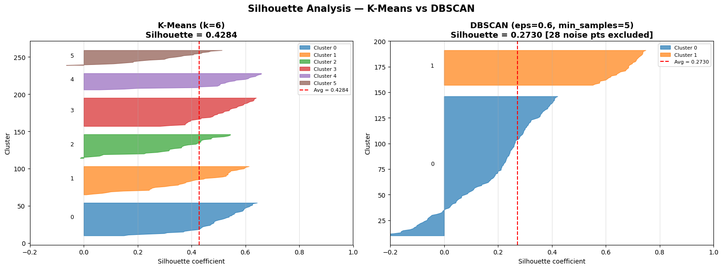

2.2 Secondary Metrics
- Davies-Bouldin Score — measures average similarity between each cluster and its most similar neighbour. Lower is better. Penalises clusters that are large and close to each other.
- Calinski-Harabasz Score — ratio of between-cluster dispersion to within-cluster dispersion. Higher is better. Rewards compact, well-separated clusters.

2.3 Results
The table below summarises all intrinsic quality metrics for both algorithms. DBSCAN metrics are computed on non-noise points only (28 of 200 points were labelled as noise and excluded).

3. Discussion: Which Algorithm Suited the Dataset Better?

3.1 K-Means Results
K-Means with k=6 achieved a Silhouette Score of 0.4284, indicating moderate-to-good cluster separation. The Davies-Bouldin Score of 0.8254 is reasonably low, confirming that clusters are relatively compact. The Calinski-Harabasz Score of 135.10 is substantially high, reflecting well-defined, dense groupings across the three features (Age, Annual Income, Spending Score).

3.2 DBSCAN Results
DBSCAN metrics were calculated after excluding noise points labelled as -1, because noise points do not belong to any cluster.
DBSCAN (eps=0.6, min_samples=5) found only 2 clusters and labelled 28 points (10.5% of the dataset) as noise. All three intrinsic metrics were notably weaker than K-Means: Silhouette = 0.2646, Davies-Bouldin = 1.0328, Calinski-Harabasz = 54.92. The two clusters identified by DBSCAN are very broad and overlap considerably with each other in feature space.
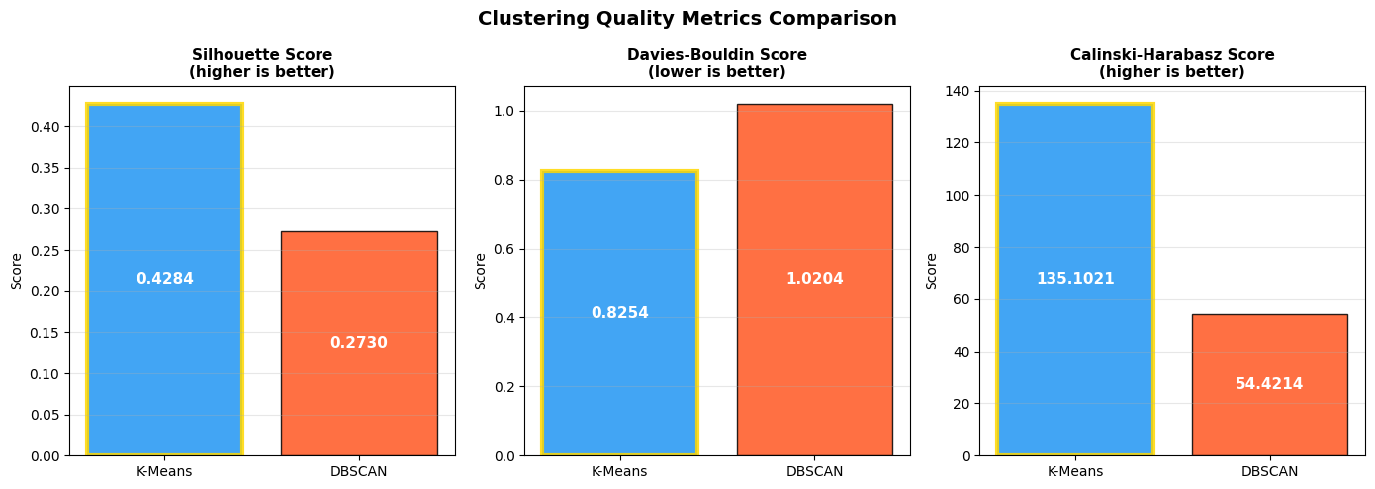
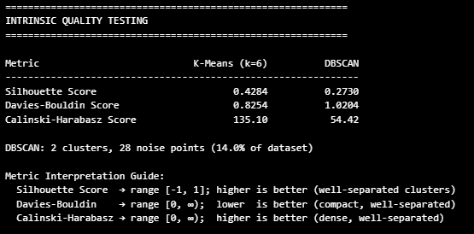
Metric | K-Means (k=6) | DBSCAN | Better
Silhouette Score (higher = better) | 0.4284 | 0.2730 | K-Means
Davies-Bouldin Score (lower = better) | 0.8254 | 1.0204 | K-Means
Calinski-Harabasz Score (higher = better) | 135.10 | 54.42 | K-Means
No. of Clusters Found | 6 | 2 + 28 noise pts | —

3.3 Conclusion
K-Means (k=6) is better suited to the Mall Customers dataset.

K-Means outperformed DBSCAN on every quality metric:
- Silhouette Score: 0.4284 vs 0.2730— K-Means clusters are substantially better separated and more cohesive.
- Davies-Bouldin Score: 0.8254 vs 1. 0204— K-Means clusters are more compact with less overlap.
- Calinski-Harabasz Score: 135.10 vs 54.42 — K-Means achieves much denser and more distinct cluster structure.

There are three key reasons why K-Means suits this dataset better:

1. Convex, roughly spherical cluster shapes
Mall customer segments (e.g., high-income/high-spending vs. low-income/low-spending) form roughly spherical blobs in feature space. K-Means assumes exactly this geometry, whereas DBSCAN is designed for arbitrarily shaped clusters and gains no advantage here.

2. Relatively uniform point density
DBSCAN excels when clusters have varying densities or when anomaly detection is a goal. The Mall Customers data has fairly uniform density across segments. As a result, DBSCAN could not distinguish fine-grained sub-groups and collapsed them into only two large clusters while flagging 28 points as noise.

3. Business goal alignment
The application goal is customer segmentation for targeted marketing. K-Means' 6 clusters deliver actionable, interpretable groups — for example, young customers with low income but high spending enthusiasm, versus older customers with high income but conservative spending. DBSCAN's 2-cluster solution lacks the granularity needed for meaningful marketing strategies.

When would DBSCAN be preferred?
DBSCAN would be the better algorithm if the dataset exhibited irregular cluster shapes (e.g., ring or crescent structures), highly varying densities across groups, or if identifying genuine outlier customers were a priority. None of these conditions are dominant characteristics of the Mall Customers dataset, making K-Means the recommended algorithm for this task.

